**Section 5: The Greatness of the Buddha**

As a fully awakened Buddha, the Blessed One had amazing and wonderful qualities. In this section we are going to relate some of the significant events in the Buddha’s life that demonstrate his extraordinary qualities.

**▲ The Buddha’s Supreme and Noble Qualities**

In earlier sections we saw how the Buddha, with his great ability and wisdom, defeated Māra’s tenfold army and became the fully Enlightened One—a Samma Sambuddha. In this section we will highlight some of special qualities of the Blessed One, which he gained by becoming a Fully enlighten being.

The Buddha had extraordinary qualities that no other being in the three worlds [1] possessed. Being a Samma-Sambuddha, one who discovered the ‘Path to Enlightenment’, he possessed a wide range of special powers and knowledges, some of which were also attained by noble disciples, but some superior knowledges which are only possessed by a fully enlightened being—a Samma Sam Buddha.

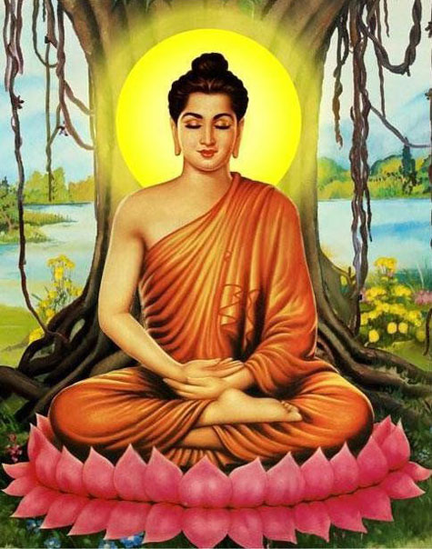

**The Fully Enlightened Buddha:** Picture Courtesy: divaina.lk

Divaina News Paper, Colombi Sri Lanka

**▲ The Greatness of the Buddha is Unconceivable**

The supremacy of the Blessed One is unimaginable— only another Buddha can comprehend the knowledge of a Buddha.The following sutta makes this point:

“*The domain of the Buddhas is an inconceivable matter that one should not try to conceive; one who tries to conceive it would reap either madness or frustration.”[2]*

**▲No one in the three worlds can rival the Buddha**

The following sutta compares the Buddha to a lion. The lion, king of beasts, cannot be surpassed by other animals. In same way, the Blessed One is unsurpassed in this world with its devas, humans and other beings. He was the one who set in motion the Wheel of the Dhamma called the ‘Brahmā Wheel’ (great wheel). He taught the pure Dhamma for the benefit of all sentient beings.

“ He is the Blessed One, the Buddha,

he is the lion unsurpassed; in this world with its devas,

he set in motion the wheel of Brahmā.

Thus, those devas and human beings

who have gone for refuge to the Buddha

assemble and pay homage to him,

the great one free from diffidence:

Tamed, he is the best of tamers;

peaceful, he is the seer among peace-bringers;

freed, he is the chief of liberators;

crossed over, he is the best of guides across.”

Thus, indeed they pay him homage,

the great one free from diffidence.

In this world together with its devas,

there is no one who can rival you,” [3]

*“The Realized One, compassionate for all living creatures, unstintingly offers teaching. Sentient beings revere him, first among gods and humans, who has gone beyond rebirth.”* [4] .

**▲ The Buddha Possesses Special Knowledges**

The Buddha has special abilities which came to him at the attainment of Buddhahood. They are called the ‘**Ten Powers**’.

*“ Sāriputta, the Tathāgata has these ten Tathāgata’s powers, possessing which he claims the herd leader’s place, roars his lion’s roar in the assemblies, and sets rolling the Wheel of Brahmā…”* [5]

**♦ The Ten Powers**

1) The Tathāgata understands as it actually is the possible as possible and the impossible as impossible (the power of knowing what is true and what is not true) [6] .

2) The Tathāgata understands as it really is the result of the undertaking of kamma past, future, and present in terms of possibilities and causes (the power of understanding kamma and its results of all beings) [7] .

3) The Tathāgata understands as it actually is the ways leading to all destinations (the power of knowing rebirths of beings, whether they will be born in a higher realm or a lower one) [8].

4) The Tathāgata understands as it actually is the world with its many and different elements.

5) The Tathāgata understands as it actually is how beings have different inclinations (he understands that beings are of inferior inclinations and superior inclinations, and that they gravitate towards those who share their own inclinations).

6) The Tathāgata understands as it actually is the disposition of the faculties of other beings (his knowledge of the superiority and inferiority of beings’ faculties of faith, energy, mindfulness, concentration, and wisdom) [9] .

7) The Tathāgata understands as it actually is the defilement, the cleansing, and the emergence in regard to the jhānas, liberations, samādhi, and attainments [10] .

8) The Tathāgata recollects his manifold past lives [11] .

9) With the divine eye, which is purified and surpasses the human, the Tathāgata sees beings passing away and reappearing, inferior and superior, fair and ugly, fortunate and unfortunate [12].

10) By realising for himself with direct knowledge, the Tathāgata here and now enters upon and abides in the deliverance of mind and deliverance by wisdom that are taintless with the destruction of the taints.

**♦ The Six Unshared Supernormal Knowledges of the Buddha**

The following supernormal knowledges are not shared with noble disciples and are called *asādhārana ñāna:* knowledge of the maturity levels of the five spiritual faculties (*indriya paropariyatte ñāna*) [13] knowledge of the dispositions and underlying tendencies of beings (*āsayanusaya ñāna*) [14] knowledge of the twin miracle (*yamakapātihāra ñāna*) [15]; knowledge of the attainment of great compassion (*mahā karunāsamāpattiya ñāna*) [16];

knowledge of omniscience (*sabbannuta ñāna*) [17]; and knowledge of unobstructiveness (*anāvarana ñāna*) [18] .

**Note:** The Patisambhidāmagga described 73 knowledges possessed by the Buddha, 67 shared with his noble disciples. Only the six called a*sādhārana ñānas* (**see** above) are unique to the Buddha.

**▲The Nine Most Important Noble Qualities of the Buddha**

According to the scriptures, there are innumerable virtues and noble qualities of the Buddha to reflect upon. In the sutta below, we can see an abridged version highlighting **nine** main qualities. The Buddha said reflecting the noble qualities would bring peace and harmony to the mind.

*“…Mahānāma, you should recollect the Tathāgata thus [19]: ‘The Blessed One is an* ***arahan****t [20],* ***perfectly enlightened [21]****,* ***accomplished in true knowledge and conduct [22]****,* ***fortunate [23]****,* ***knower of the world*** *[24],* ***unsurpassed trainer of persons to be tamed [25]****,* ***teacher of devas and humans*** [26]*,* ***the Enlightened One [27]****,* ***the Blessed One*** *[28]…”. [29]*

**Note: The Nine Qualities of the Buddha in Pali:** *“araham sammā-sambuddho, vijjā-carana-sampanno sugato lokavidū, anuttaro purisa-damma-sārathi satthā deva-manussānam buddho bhagavā*.”

The Blessed One is accomplished, fully enlightened, endowed with clear vision and virtuous conduct, sublime, the knower of worlds, the incomparable leader of men to be tamed, the teacher of gods and humans, enlightened and blessed.

♦ **Recollecting the Noble Qualities of the Buddha Brings Peace**

The following sutta elaborates this point:

*“…When a noble disciple recollects the Tathāgata, on that occasion his mind is not obsessed by lust, hatred, or delusion; on that occasion his mind is simply straight, based on the Tathāgata. A noble disciple whose mind is straight gains inspiration in the meaning, gains inspiration in the Dhamma, gains joy connected with the Dhamma. When he is joyful, rapture arises. For one with a rapturous mind, the body becomes tranquil. One tranquil in body feels pleasure. For one feeling pleasure, the mind becomes concentrated. This is called a noble disciple who dwells in balance amid an unbalanced population, who dwells unafflicted amid an afflicted population. As one who has entered the stream of the Dhamma, he develops recollection of the Buddha” [30]*

He who found for the sake of all beings release from the snare of death; who revealed the Dhamma, the method, for the benefit of devas and humans; he in whom many people gain confidence when they see and listen to him; the one skilled in the path and what is not the path, the taintless one who accomplished his task; the Enlightened One bearing his final body is called “a great man of great wisdom.”

Quote from AN4: 35.

**▲The Buddha is the Great Man with Great Wisdom**

In this sutta we find a dialogue between brahmin Vassakāra, the chief minister of Magadha and the Buddha regarding who is the great man with great wisdom. At the end of the discourse, Vassakāra said that the Blessed One is the great man with great wisdom. Then, the Buddha said thus:

*“Indeed, I am practicing for the welfare and happiness of many people; I have established many people in the noble method, that is, in the goodness of the Dhamma, in the wholesomeness of the Dhamma. I think what I want to think and do not think what I do not want to think; I intend what I want to intend and do not intend what I do not want to intend; thus, I have attained to mental mastery over the ways of thought. I gain at will, without trouble or difficulty, the four jhānas that constitute the higher mind and are pleasant dwellings in this very life. With the destruction of the taints, I have realized for myself with direct knowledge, in this very life, the taintless liberation of mind, liberation by wisdom, and having entered upon it, I dwell in it.” [31]*

**▲The Buddha Received Honor and Respect from All Other Beings**

We can see in the following suttas the reason for the Blessed One being honored and respected:

* In the Verañjā Sutta (AN8:11), a brahmin of Verañjā approached the Buddha and said:

*“ The ascetic Gotama does not pay homage to brahmins who are old, aged, burdened with years, advanced in life, come to the last stage; nor does he stand up for them or offer them a seat… nor does he stand up for them or offer them a seat. This is not proper, Master Gotama…”*

The Buddha replied:

*“Brahmin, in the world with its devas, Māra, and Brahmā, in this population with its ascetics and brahmins, its devas and humans, I do not see one to whom I should pay homage, or for whom I should stand up, or whom I should offer a seat. For if the Tathāgata should pay homage to anyone, or stand up for him, or offer him a seat, even that person’s head would split.”*

♦ **The Blessed One Honoured the Dhamma**

Soon after his enlightenment, the Buddha was reflecting thus:

“*Now what ascetic or brahmin can I honour and respect and dwell in dependence on?...... I do not see another ascetic or brahmin more perfect in the knowledge and vision of liberation than myself, whom I could honour and respect, and on whom I could dwell in dependence…* *“Let me then honour, respect, and dwell in dependence on this very Dhamma to which I have fully awakened.” [32]*

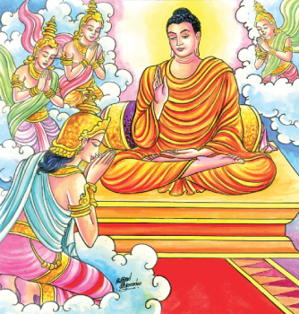

**Devas paying homage to the Buddha:** Picture Courtesy: Budusarana News Paper, Sri Lankahttps://www.budusarana.lk/budusarana/

**♦ Devas Paying Homage to the Buddha**

In the Vinaya Pitaka we read of the four great kings, Sakka and Brahma Sampatti visiting the Buddha in Uruvelā Kassapa’s hermitage, and paying homage to him. [33]

There are many suttas in the Samyutta Nikaya (e.g. Devatasmayutta, Devaputtasamyutta, Brhamasmyutta, Sakkasdamyutta and Yakkasamyutta), describing events where Devas, Brahmas, Asuras and Yakkas and other beings visit the Buddha to pay homage to him.

**♦ The Buddha Receive Homage because He is the Most Senior Being in the World**

The scriptures described the Buddha as the most senior and eldest person in the world.

*“…brahmin, in a population immersed in ignorance, become like an egg, completely enveloped, I have pierced the eggshell of ignorance. I am the sole person in the world who has awakened to the unsurpassed perfect enlightenment. So, I am the eldest, the best in the world.” [34]*

♦ **The Buddha is the Elder in the World**

The Buddha said:

*“Who has abandoned birth and death, consummate in the spiritual life, in whom there are no taints— he is the one I call an elder. With the destruction of the taints a bhikkhu is called an elder”.[35]*

**▲The Buddha is Skilful in All Three Deeds**

The Buddha has mastery of deeds done by body, speech and mind. On one occasion remembering his past life as a king’s chariot-maker the Buddha said:

*“…then I was skilled in crookedness, faults, and defects in wood. But now I am the Arahant, the Perfectly Enlightened One, skilled in crookedness, faults, and defects of the body; skilled in crookedness, faults, and defects of speech; and skilled in crookedness, faults, and defects of mind…”[36]*

**▲The Buddha is the Most Excellent Speaker**

The Buddha is the best of speakers because he speaks the Truth—the Dhamma his excellent words has helped many hundreds and thousands of beings from bondage.

*“Knowledge is the best of things that rise up;*

*Ignorance excels among things that fall down;*

*The Saṅgha is the best of things that go forth;*

*The most excellent of speakers is the Buddha”[37]*

**▲The Blessed One was the Arouser of the Unarisen Path**

On one occasion the brahmin Gopaka Moggallāna, approached and asked Venerable Ānanda Thera:

“*Master Ānanda, is there any single bhikkhu who possesses in each and every way all those qualities that were possessed by Master Gotama, accomplished and fully enlightened?”*

Venerable Ānanda replied:

*“… There is no single bhikkhu, brahmin, who possesses in each and every way all those qualities that were possessed by the Blessed One, accomplished and fully enlightened. For the Blessed One was the arouser of the unarisen path, the producer of the unproduced path, the declarer of the undeclared path; he was the knower of the path, the finder of the path, the one skilled in the path. But his disciples now abide following that path and become possessed of it afterwards…”[38]*

**▲Wonderful and Marvelous Qualities of the Buddha**

In Section One of this series, we have seen some of the wonderful and marvellous qualities of the Boddhisatva—the Buddha to be. In the scriptures there are innumerable places pointing out the wonderful and marvellous qualities of the fully awakened Buddha. We have selected a few suttas to elaborate on this point:

In the following sutta the Buddha says:

*“The Tathāgatas, Ānanda, are wonderful and possess wonderful qualities; the Tathāgatas are amazing and possess amazing qualities”[39].*

**♦The Buddha Possessed Numerous Psychic Abilities**

The many psychic powers of the Buddha were called wonderful and marvellous qualities. These abilities varied: being many, he could become one; he appears and disappears; he passes through fences, walls and mountains unhindered as if through air; he sinks into the ground and emerges from it as if it were water; he walks on the water without breaking the surface as if on land; he flies cross-legged through the sky like a bird with wings; he even touches and strokes with his hand the sun and moon, mighty and powerful as they are; and he travels in the body as far as the Brahmā world.[40]

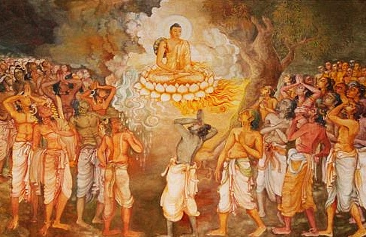

**Buddha’s Great Miracles**: Picture courtesy: Kagyu Shenpen Kunchab Buddhist Centre

<https://nobletruth.org/>

**♦Ability to Appear in the Brahmā World**

At one time Venerable Ānanda approached the Blessed One and asked:

“*Venerable sir, does the Blessed One recall ever having gone to the Brahmā world by spiritual power with a mind-made body?”*

The Buddha replied:

*“When, Ānanda, the Tathāgata immerses the body in the mind and the mind in the body, and when he dwells having entered upon a blissful perception and a buoyant perception in regard to the body, on that occasion the body of the Tathāgata rises up without difficulty from the earth into the air. He wields the various kinds of spiritual power: having been one, he becomes many; having been many, he becomes one; … he exercises mastery with the body as far as the Brahmā world”[41]*

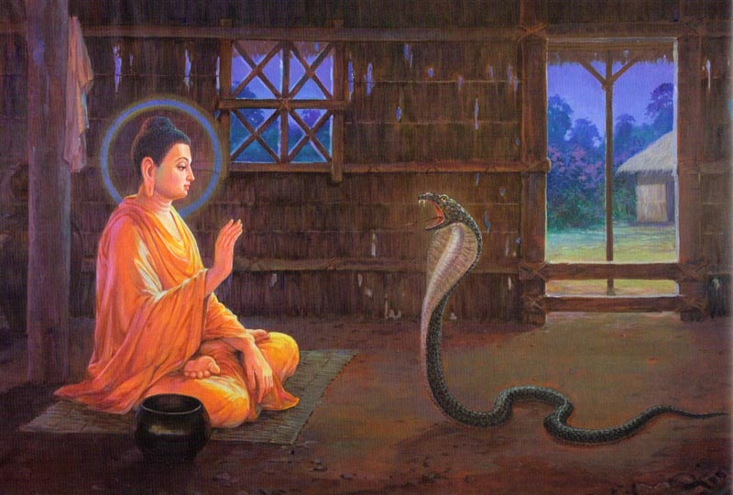

**Encounter with a Naga serpen**t: Source: the Illustration from “The Life of the Buddha in Pictures.” Courtesy: Dhammatalks.net

**♦Performances of Miracle at the Monastery of Uruvela Kassapa**

In the Vinaya Pitaka it describes [42] several performances of miracles by the Blessed One at the hermitage of Uruvelā Kasspa. It seems such events led to the conversion of Uruvelā Kassapa, a famous Jatila teacher at that time in Magadha and his two brothers, Nadī Kassapa, and Gayā Kassapa, who established faith in the Blessed One and became his disciples [43]. We have selected the following incident: an encounter with a Naga serpent—a venomous dragon king who lived in the ‘Fire Hut’ of Uruvelā Kassapa.

“*The Buddha entered the fire hut and prepared a spread of grass. He sat down, crossed his legs, straightened his body, and established mindfulness in front of him. When the dragon saw that the Buddha had entered, he was displeased and emitted smoke.”.*

The Buddha thought:

*“Let me overpower this dragon, using fire against fire, but without harming it in the slightest way…*”

The Buddha then used his supernormal powers so that he, too, emitted smoke. The dragon, being unable to contain his rage, emitted flames. The Buddha entered the fire element and he, too, emitted flames. With both of them emitting flames, it was as if the fire hut was ablaze and burning. The dreadlocked ascetics gathered around the fire hut, saying:

*“The Great Ascetic is handsome, but the dragon is harming him…”*

The next morning the Buddha had overcome that dragon, using fire against fire, but without harming it in the slightest way. He put it in his alms bowl and showed it to Uruvelā Kassapa:

“*Here is your dragon, Kassapa, his fire overpowered by fire*.” [44]

**Note:** Here we clearly see that the Buddha has shown his psychic power only on special occasions such as the taming of the serial killer Angulimāla and the great miracle he performed to break the pride of the Sakyas in the city of Kapilavastu.

* **The Only Miracles the Buddha Approved**

In Kevaddha Sutta (DN:11) the Buddha says this to the brahmin Kevaddha who urged the Buddha to perform miracles to gain the faith of people in the city of Nālanda.

“*Kevaddha, this is not the way I teach Dhamma to the monks, by saying:’ Go,*

*monks, and perform superhuman feats and miracles for the white-clothed lay-people…*

*…Kevaddha, there are three kinds of miracle that I have declared, having realised them by my own insight. Which three? The* ***miracle of psychic power,*** *[45] the* ***miracle of telepathy [46]****, the* ***miracle of instruction…[47]****”*

The Blessed One then warns Kevaddha that the miracle of psychic power and the miracle of telepathy have many dangers, hence he dislikes, rejects and despises them. The only miracle the Blessed One approved of was the miracle of instruction—the ability to transform a person through teaching the Dhamma; when one follows the teaching ardently, one can realise the truth for oneself.

* **Noble Qualities are the True Wonders**

The following stanza is the way the Buddha called attention to the quality he regarded as a true wonder and marvel [48]

*“…Ānanda, remember this too as a wonderful and marvellous quality of the Tathāgata: Here, Ānanda, for the Tathāgata feelings are known as they arise, as they are present,*

*as they disappear; perceptions are known as they arise, as they are present, as they disappear; thoughts are known as they arise, as they are present, as they disappear. Remember this too, Ānanda, as a wonderful and marvellous quality of the Tathāgata.”[49]*

**▲The Marks of the Great Man**

It is shown in the scriptures that the Buddha had not only great spiritual qualities but also extraordinary physical features. The Lakkhaṇa Sutta (DN:30) outlines the thirty-two physical attributes of the Blessed One. [50]

*“There are, monks, these thirty-two marks peculiar to a Great Man, and for that Great Man who possesses them, only two careers are open. If he lives the household life, he will become …a wheel-turning monarch; But if he goes forth from the household life into homelessness, he will become an Arahant, a fully enlightened Buddha…”*

**Note:** In the Mahapadana Sutta (DN: 14), it gives a detailed description of the thirty-two marks attributed to the Buddha Vipassi.

**♦ The Thirty-Two (32) Marks** **of a Great Man**

(1) He has feet with level tread [51] (2) On the soles of his feet has the impression of a thousand-spoked wheel. (3) He has projecting heels. (4) He has long fingers and toes [52] (5) He has soft and tender hands and feet. (6) His hands and feet are net-like [53] (7) He has high-raised ankles [54] (8) His legs are like an antelope’s. (9) Standing and without bending, he can touch and rub his knees with either hand. (10) His male organs are enclosed in a sheath. (11) His complexion is bright, the colour of gold. (12) His skin is delicate and so smooth that no dust can adhere to his body. (13) His body-hairs are separate, one to each pore. (14) His body-hairs grow upwards, each one bluish-black like collyrium, curling in rings to the right. (15) His body is divinely straight [55] (16) He has the seven curved surfaces [56] (17) The front part of his body is like a lion’s. (18) There is no hollow between his shoulders. (19) He is proportioned like a banyan-tree: the height of his body is the same as the span of his outstretched arms, and conversely. (20) His bust is evenly rounded. (21) He has a perfect sense of taste (22) He has jaws like a lion’s. (23) He has forty teeth. (24) His teeth are even. (25) There are no spaces between his teeth. (26) His canine teeth are very bright. (27) His tongue is very long. (28) He has a Brahmā-like voice, like that of the karavīka-bird. (29) His eyes are deep blue. (30) He has eyelashes like a cow’s. (31) The hair between his eyes is white and soft like cotton-down [57] (32) His head is like a royal turban a bulge/ knot on the top of the head [58]

♦ **Some More Evidence from the Scriptures Regarding the Thirty-Two Great Marks**

In Section Four of this series, we saw the Buddha as the Supreme Being —a Fully Enlightened Buddha possessing all the noble qualities. Many suttas in the Sutta Pitaka describe the Buddha's noble qualities as well as his beautiful body. We have selected a few extracts from the scriptures where the physical bodily qualities of the Blessed One were described:

* **Discovery of Brahmin Student Uttara**

According to the Brahmāyu Sutta (MN:91) the Brahmāyu, sent his student Uttara to verify the report spread about the Buddha in his community as being true or not. He instructed his student to check all the noble qualities and also the so-called thirty-two physical marks attributed to the Buddha. Agreeing to fullfill his teachers wish, Uttara

followed the Blessed One for seven months like a shadow, never leaving him. At the end of the seven months, he went to his teacher and reported:

*“…the report that has been spread about Master Gotama is true, sir, and not otherwise; and Master Gotama is one such as this and not otherwise. He possesses the thirty-two marks of a Great Man…”*

**Note:** In his report to his teacher, Uttara described the thirty-two physical features of the Blessed One.

**\* Confirmation of the Brahmin Sela**

According to the Sela Sutta (MN:92), on one occasion the brahmin Sela, who was a great teacher of that time—Master of the three Vedas…fully versed in the marks of the Great Man…, accompanied by three hundred students met the Blessed One seated in green grove with some of his bhikkhu disciples. He approached the Buddha, exchanged greetings and sat down nearby and looked for the thirty-two marks of a Great Man on the Blessed One’s body, seeing all of them except two. The Blessed One, knowing that doubt occurred in the mind of Sela, performed a feat of supernormal power so the brahmin Sela saw the missing two marks. Then Sela said thus:

“O perfect in body, well favoured,

Well fashioned and lovely to behold;

O Blessed One, golden is your colour,

And white your teeth; you are strong.

The features are seen one and all

That distinguish a man as well born;

They are all to be found on your body,

These marks that reveal a Great Man”[59]

**\* The Brahmin Dona witnessing the Footprints of the Buddha**

In the Dona Sutta (AN4: 36) describes how the brahamin Dona, who was travelling on the highway between Ukkaṭṭhā and Setavya, saw the thousand-spoked

wheels of the Blessed One’s footprints, with their rims and hubs, complete in all respects, and thought: “*It is astounding and amazing! These surely could not be the footprints of a human being!”.*

Then Doana saw the Buddha sitting near the foot of a tree, went there and asked the Buddha weather he was deva or gandhabba or any superbeing. The Blessed One said that he is awaken being—the Buddha.

* **How the Brahmin Student Ambatta’s Doubt Disappeared**

According to the Ambatta Sutta (DN:3), Ambatta the student of the brahamin Pokkharasati was walking with the Buddha and looked out for the thirty-two marks of a Gret Man on the Blessed One’s body., seeing all of them except for two. He was in doubt and perplexity about these two marks. The Buddha, being aware of his doubts, enabled Ambattha tp see those two marks on his body using his psychic powers.

Then Ambattha went to see his teacher and reported thus:

“*Sir, he (the Buddha) is as he is reported to be, and he is of such nature and not otherwise. He is possessed of the thirty-two marks of a Great Man, all complete, with none missing” .*

**\* The Brahmin Bāvari’s Descriptions of how to Recognise the Buddha**

On one occasion the brahmin Bāvari, asked his students to go and see the Buddha and ask a question about “what is head splitting?”. But first the students wanted to know how to recognize the Buddha, and Bāvari said thus:

*“The marks of a Great Man have been handed down in our hymns. Thirty-two have been described, complete and in order. One upon whose body is found these marks of a Great Man has two possible destinies, there is no third. If he stays at home, having conquered this land without rod or sword, he shall govern by principle. But if he goes forth from the lay life to homelessness,he becomes an Awakened One, a perfected one, with veil drawn back, supreme”[60].*

Then the students went seeking the Buddha and finally met him:

*“Ajita saw the Buddha,*

*like the sun shining with a hundred rays,*

*like the moon on the fifteenth day*

*when it has come into its fullness.*

*Then he saw his body, in all features.*

*Thrilled, he stood to one side and*

*asked this question in his mind.”[61]*

* The **Brahamin Soṇadaṇḍa Declaring the Thirty-Two Marks upon the Blessed One**

On one occasion the Buddha arrived in the country of Angha and stayed near by the city of Champa. Soṇadaṇḍa, a well-known brahmin of that city, planned to visit the Blessed One. Then his followers heard the news and said it was not fitting for him to go and see Master Gotama, instead Master Gotama should visit him. They gave the following reasons:

*“…the Reverend Sonadanda is handsome, good-looking, pleasing, of the most beautiful*

*complexion, in form and countenance like Brahmā, of no mean appearance… He is aged, grown old, venerable, advanced in years, long past his youth, whereas the ascetic Gotama is youthful and newly gone forth as a wanderer. The Reverend Sonadanda is esteemed, made much of, honoured, revered, worshipped by King Seniya Bimbisara …etc. This being so, it is not proper that he should visit the ascetic Gotama, but rather the ascetic Gotama should visit him…”[62]*

Then the brahmin Soṇadaṇḍa said thus:

*“This good report has been spread about him: “This Blessed Lord is an Arahant, a fully-enlightened Buddha, perfected in knowledge and conduct...He bears the thirty-two marks of a Great Man… Indeed, King Seniya Bimbisara of Magadha has gone for refuge to him… Having come to Gaggara’s lotus-pond, the ascetic Gotama is such a guest, and should be treated as such. Therefore, it is not proper that he should come to us, but rather we should go to him”.*

* **King Bimbisara Has Seen the Great Marks of Ascetic Siddhartha**

When the Buddha was just an ascetic wandering in Magadha (see, Section Three), King Bimbisara saw him. This is what the scriptures says:

*The Buddha went to Rājagaha,*

*the Mountainfold of the Magadhans.*

*He betook himself for alms,*

*replete with excellent marks.*

*Bimbisāra saw him*

*while standing atop his longhouse.*

*Noticing that he was endowed with marks,*

*he said the following:*

*‘Pay heed, sirs, to this one,*

*handsome, majestic, radiant…”[63]*

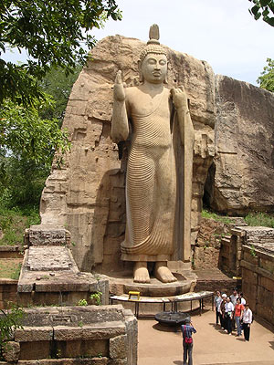

**A Standing Buddha-** Avukana, Sri Lanka: Picture courtesy: Buddha Net

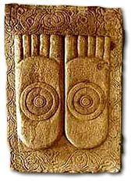

**The Buddha’s Feet**: Picture courtesy: Buddha Net.

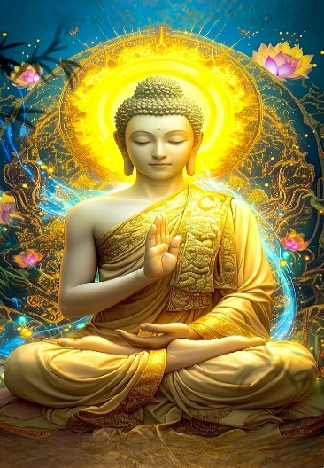

**Golden Skin colour of the Buddha:** Picture courtesy: Pinterest

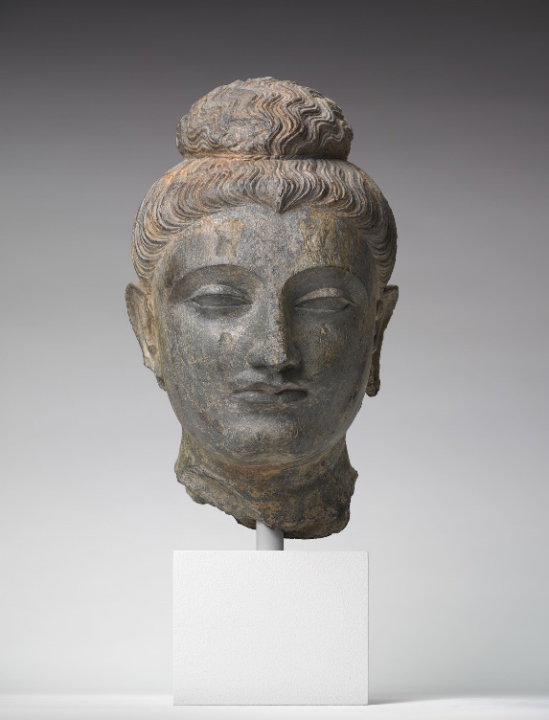

**The Buddha’s Head**: Picture courtesy: Harvard Museum

**End Notes: Section 5**

1. The Three worlds according to the scriptures are the Brahma world, the Deva world and the Human world. For more information: see: Introduction to DN: Cosmology: The Long Discourses of The Buddha by Maurice Walshe.
2. AN4: 77.
3. AN4: 23. * In AN4: 334, the Buddha compared himself to a lion.
4. Iti: 112 (Loka Sutta: Translated by Bhikhu Sujato, www.suttacentral.net)
5. MN: 12 (Mahāsīhanāda Sutta)* In AN10: 21, The Lion sutta also mentioned similar facts.
6. Majjima Attakatha explains this as the knowledge of the correlations between causes and their results. **See:** MN: Notes: 182, p. 1081.
7. An example of this knowledge is the Buddha’s analysis of kamma. See: MN: Notes: 183, p. 1081.
8. The Buddha’s knowledge of the paths leading to hell, the animal realm, the spirit world, the human world, the deva world, and nibbāna. See: AN: Notes: 1984, p. 677.
9. See: MN: Notes: 187, p. 1082.
10. The “defilement” (sankilesa) is a state causing deterioration, “cleansing” (vodāna) a state causing excellence, “emergence” (vuṭṭāna) is both cleansing and the rising out of an attainment. The eight liberations (vimokkhā) are enumerated in MN 77.22 and MN 137.26; the nine attainments (samāpatti) are the four jhānas, four immaterial attainments, and the cessation of perception and feeling. MN: Notes: 188, p. 1082.
11. In MN: 4 (Bhayabherava Sutta) , the Buddha said: “…I recollected my manifold past lives, that is, one birth, two births, three births, four births, five births, ten births, twenty births, thirty births, forty births, fifty births, a hundred births, a thousand births, a hundred thousand births, many aeons of world-contraction, many aeons of world-expansion, many aeons of world-contraction and expansion: ‘There I was so named, of such a clan, with such an appearance, such was my nutriment…” Note: The Buddha can recollect 91 aeons back: see: SN: 42: 9.
12. This power is explained in MN: 4.
13. With this knowledge the Buddha can recognise the potential of persons who could benefit from his teachings, then he selects the suitable Dhamma subject which would help that person. If the **five faculties (***pancha iṅdriya)*: faith, energy, mindfulness, samādhi and wisdom are matured, a person can easily comprehend the Dhamma. **See**: KN: Patisambhidāmagga: ñāna katha
14. This refers to the understanding of mental dispositions and latent tendencies of a person and accordingly the Buddha delivers suitable teaching to them. **See**: KN: Patisambhidāmagga: ñāna katha.
15. This is a unique event in the life of the Buddha where he created two opposite elemental characteristics. On that occasion the Blessed One produced fire from the one part of the body and water from the other part of the body. Six coloured rays emerged from every pore. **See**: KN: Patisambhidāmagga: ñāna katha.
16. Through this knowledge the Buddha has great compassion for the welfare of all beings. He sees beings who are immersed in the flood of samsara and extends his unlimited support to help them cross over and be free. This is the reason the Buddha is called ‘the Great Compassionate One’. **See**: KN: Patisambhidāmagga: ñāna katha.
17. This is called ‘all-knowing’—the Buddha possessed the knowledge of everything that he needed to know about living beings and the world, therefore he is called ‘the Omniscient One’ (Sarvangnna). With this knowledge the Buddha has the ability to direcrt his mind to any object he wished to know. **See**: KN: Patisambhidāmagga: ñāna katha.
18. This means without any obstruction the Buddha can understand everything,.Patisambhidāmagga says that this and the knowledge of Omniscience are linked together. **See**: KN: Patisambhidāmagga: ñāna katha.
19. Recollection of the Buddha: *araham sammā-sambuddho, vijjā-carana-sampanno sugato lokavidū, anuttaro purisa-damma-sārathi satthā deva-manussānam buddho bhagavā*.”

    That Blessed One is such since he is accomplished, fully enlightened, endowed with [clear] vision and [virtuous] conduct, sublime, the knower of worlds, the incomparable leader of men to be tamed, the teacher of gods and men, enlightened and blessed.
20. Araham:rid of all impurities and defilements of the mind. Because of this quality the Buddha is worthy of receiving gifts and alms from any being in the world system.
21. Sammāsambuddho: the Fully Enlightened One who has discovered the Truth: four noble truths.
22. Vijjācaraṇa sampanno : he has the noble vision/knowledge and noble conduct. Through his vision he was able to destroy all taints and become liberated. He then guided other beings to free from samsara. The Blessed One’s conduct is noble and pure, harmless and beneficial to all beings.
23. Sugato: sublime one: one who has reached the right and highest destination—nibbana.
24. Lokavidū: The Buddha has the knowledge and the power to see the entire world system.
25. Anuttaro purisa-damma sārathi : The Buddha is the unparalleled leader who has the ability to tame beings who wish to be tamed.
26. Satthā Deva-manussānam: The Blessed One is the teacher, the guide/instructor to all beings of the Three Worlds who desire to be free from suffering.
27. Buddho: The Blessed One is awakened, awakened from the world immersed in darkness (ignorance). In MN:92 (the Sela sutta) , the Buddha said thus: “What must be known is directly known, what must be developed has been developed, what must be abandoned has been abandoned, Therefore, brahmin, I am a Buddha.”
28. Bhagavā: the Buddha is the supreme being with noble qualities, most fortunate and liberated being; he was fortunate to escape from samsara and showed the way of escape for all other beings, so he is called the fortunate one.
29. **In** AN: 11:11 (a detailed description of these qualities is given in section:4 of this series)
30. AN:11: 11.
31. **See:** AN4:35.
32. SN: 6: 2.
33. VP:Mahākhandaka: 12 The account of the wonders at Uruvelā: translated from Pali by Bhikkhu Brahmali
34. AN:8: 11.
35. AN4:22.
36. AN:3: 15.
37. SN1:74.
38. MN: 108 (Gopakamoggallāna Sutta)
39. SN51: 22.
40. See: DN: 2 (Sāmaññaphala Sutta, para: 87) **Note**: The following suttas also described the powers: DN: 11 (Kevadda Sutta)  & DN:12 (Lohicca Sutta) and MN: 77 (Mahasakuludayi Sutta) & SN: 51:Iddipadasmyutta suttas.
41. SN51: 22 .
42. VP: Mahakhandaka:12: The account of the wonders at Uruvela: translated from Pali by Bhikkhu Brahmali. * It says that the Blessed One performed ‘three and a half thousand wonders.’.
43. The three brothers became disciples of the Buddha with their students; listening to the Adithha Pariya Sutta—the fire sermon in SN: all of them became arahants. Details of the event is given in Section13-B (45 years of the Blessed One’s Life).
44. VP: Mahakhandaka: 12.
45. Iddhi-pāṭihāriya: ‘miracle of iddhi’- psychic powers.
46. Able to read the minds of other beings, their mental states, their thoughts and ponderings: “That is how your mind is, that is how it inclines, that is in your heart.”
47. A monk gives instruction as follows: “Consider in this way, don’t consider in that, direct your mind this way, not that way, give up that, gain this and persevere in it.”. Then following the instructions, the disciple is able to be free from suffering.
48. Observation of Ven. Bhikkhu Bodhi, see: MN: Notes: 1166, p. 1169.
49. MN:123 (Acchariya-abbhūta Sutta).
50. “The thirty-two marks, enumerated … are the subject of an entire sutta in the Dı̄gha Nikāya,

    DN 30, *Lakkhaṇa Sutta*. There each of the marks is explained as the kammic consequence of a particular virtue perfected by the Buddha during his earlier existences as a bodhisatta” See: MN: Note: 851.
51. It means flat feet.
52. Having the fingers all of the same length, and the toes likewise.
53. Reticulated.
54. With the ankle half-way up the calf.
55. Like Brahmā.
56. The backs of the four limbs, the shoulders and the trunk are well-rounded.
57. A hairy mole.
58. The 32 marks are also mentioned in the following suttas: DN:4, MN: 91 & MN:92..
59. See also: Snp:3.7 (with Sela, translated from Pali by Bhikkhu Bodhi)
60. Snp:5.1 Translated by Bhikkhu Sujato.
61. Ibid.
62. DN:4 (Sonadanda Sutta)
63. Snp:3.1 (Pabbaja Sutta, translated by Bhikkhu Sujato).